Exercise 2: Adding income elasticities

Task: Introduce income elasticities to the demand equation. In this exercise you will learn the following new features/functions in GAMS: (i) summation function (SUM); (ii) add a new equation; (iii) add new variables and parameters

Demand curve 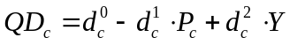
Supply curve 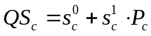
Income 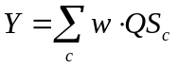
Equilibrium 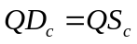

New variables income
New parameters 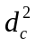 income elasticity of demand
wage rate per unit of output (quantity supplied)

Hints and tips:
- Start by changing/adding the equations. Then identify what new variables and parameters you’ll need for these equations. Good practice is to work through the necessary changes in the following order: (i) equations; (ii) model; (iii) sets; (iv) parameters; (v) variables.
- You will need to add one new equation (INCOME), one new variable (Y) and three new parameters (Y0, w, d2).
- The initial level of income (Y) is 600, while the initial wage rate (w) is 2.
- Use the following line of code to calculate the income elasticity of demand:
d2(C) = 0.75 * (QD0(C)/Y0)
- Don’t forget that you recalculate the demand curve intercept now that you’ve added a new term to the demand equation.
- Income (Y) is total income across all commodities (i.e., it is a sum of incomes from each commodity). Therefore, in the income equation you will need to use the summation function (SUM). So the income equation is as follows:
Y =E= SUM(C, w*QS(C));

Simulation: Use the same simulation as was used in exercise 2 (i.e., simulate a 20% decrease in the agricultural supply curve intercept term).

Questions
- How do the following variables change after simulating the supply shock for agriculture? Quantity demanded (QD); Quantity supplied (QS); Prices (P)
- How do the results from the model in this exercise differ from those in exercise 1? Why are there these differences? (use graphs to explain your answer)
- Why did the quantity demanded of industrial goods go down when the supply shock was only on agricultural goods?

